**The Ark Documentation.**

**Biospecimen Upload.**

Log in and select your study.

Once you have chosen your study we will see the following functions. Click the LIMS function in the top row.

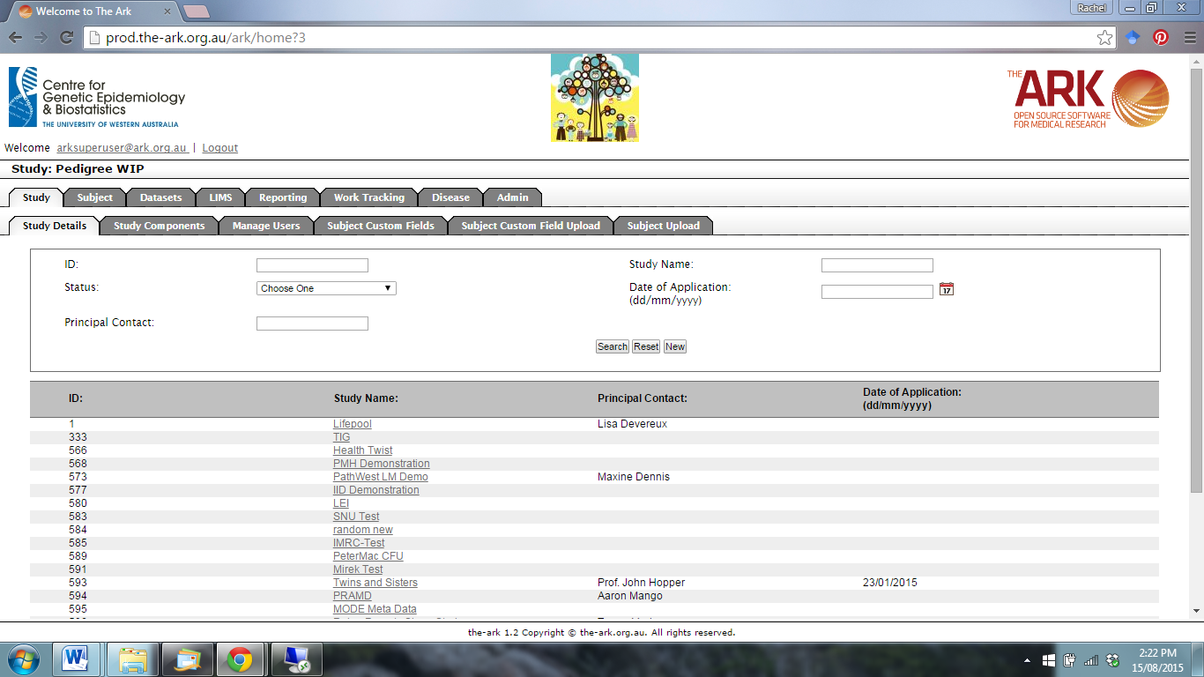

The following page will appear. Select the Biospecimen Upload function.

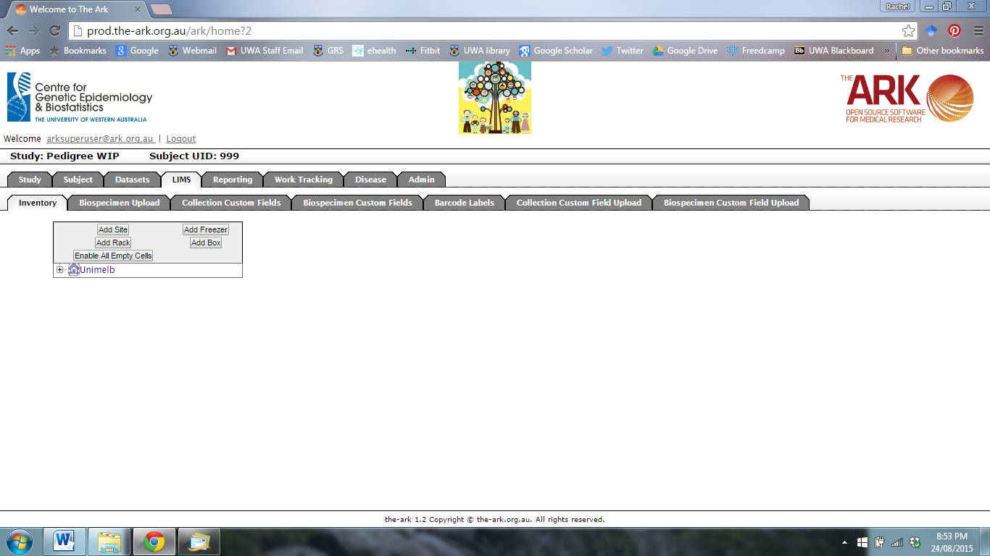

The following page will appear.

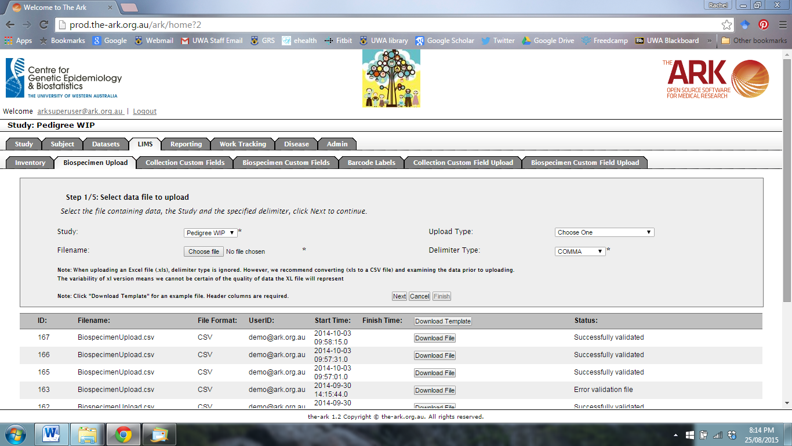

Select the study you wish to upload to. Use the Choose file function to upload a CSV file with the upload information.

If you use another file type, you can select the appropriate delimiter type from the drop-down menu.



You can click on the “Download Template” for an example CSV file.



Below is template file for uploading biospecimens.

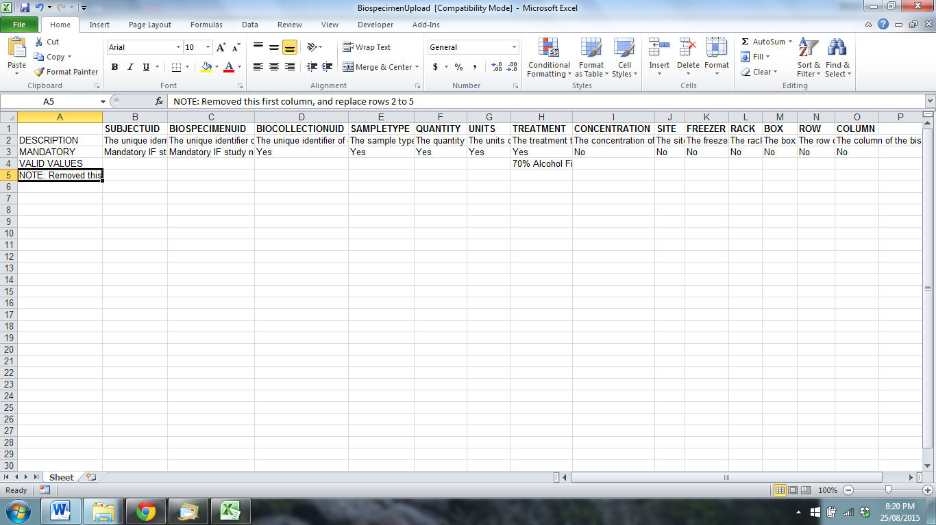

When you have finished, click Next.

